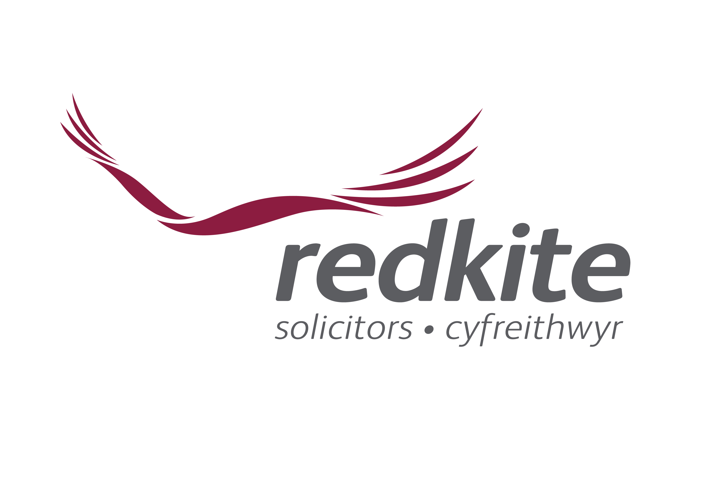

Terms and Conditions

Legal review of Terms and Conditions

We can assist in reviewing and drafting your terms and conditions of business.

In the current economic downturn with cash-flow issues creating tensions between contracting parties, it is ever more important to ensure that your terms and conditions are:
- Robust
- Clear
- Enforceable

Standard terms and conditions of business are often given a low priority by businesses and may only be given detailed consideration when a dispute arises, by which time it may be too late. In the meantime, businesses may be issuing quotations or processing orders using terms which are out of date, unsuited to the business' current needs or simply copied from terms used by the business’ competitors.

It is vitally important that you do not wait until you require payment from a customer or are threatened with litigation before you review your terms and conditions.

If your business does not have any terms and conditions at all, we can evaluate your requirements and draft appropriate and legally sound terms and conditions for a fixed fee.

Summary
We are very keen to work with and support you. Our commercial expertise means that we will understand your commercial needs and objectives. We believe our service will greatly assist you with the continuing success of your business. Our services are highly flexible and can be tailored at any time to reflect your changing needs.

Contact us

For further information please contact Paul James on

T: 01646 683222
DD: 01646 623589
F: 01646 682786
E: paul.james@redkitelaw.co.uk

www.redkitelaw.co.uk

Offices at
● Carmarthen ● Haverfordwest
● Pembroke ● Pembroke Dock
● Whitland ● Tenby
● Cleddau Bridge ● Chepstow

